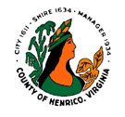 Notice
Department of Building Construction and Inspections
Henrico County, VA

TO: Interested Parties
FROM: Mechanical/Plumbing Inspection Supervisor
SUBJECT: Chimney Liner Inspections
DATE: October 1, 2024
Section 113.3.1 of the Virginia Construction Code requires that chimneys be inspected whenever they are re-lined and/or upon the replacement or new installation of any fuel-burning appliances. The inspection is required to ensure the chimney is properly sized for the equipment and to confirm that there are no obstructions, blockages or defects in the chimney. The chimney inspection can be performed either prior to, or in conjunction with, the final inspection of the new equipment installation
Chimney liner inspections performed prior to the final inspection shall be made before the appliance or equipment is installed. The final inspection shall then be requested after approval of the chimney liner inspection and installation of the appliance or equipment.
Chimney liner inspections performed at the same time as the final inspection of the equipment require that photographs be submitted prior to conducting the site inspection. Both inspections shall be requested at the same time if both have been completed. Inspections can be scheduled through your customer portal. See helpful how to videos on Build Henrico. The photographs shall be uploaded as a supplemental document to the permit that it pertains too. The photographs will be retrieved by the applicable mechanical/plumbing inspector for use during the inspection. The photographs shall include:
- the interior of the newly installed or existing chimney liner from the point of connection to termination of the liner or flue
- the interior and exterior of the vent connector at the chimney flue
- the equipment connection to the vent
- the chimney cap if one is installed
Photographs will not be approved in lieu of the field inspection of the installation. The inspector will use the photographs and the appliance manufacturer’s installation instructions to confirm code compliance during the inspection. I can be reached at (804) 501-4371 if you have any questions concerning this notice.

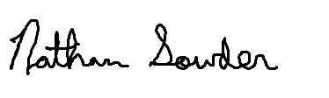
Nathan Sowder
Mechanical/Plumbing Inspection Supervisor

