GENERAL

- All plan elements shall conform to latest edition of Henrico County Design Manual, current DPW Construction policies, VDOT Road and Bridge Standards and VDOT Road and Bridge specifications.
- The latest copy of the Standard Construction Notes/Details Sheet (revised 2/19/13) must be included with the plans.
Referenced publications are out of date.
- All approved waivers must be included in plan set.
- Identify the locations of existing and proposed structures, roads, utilities and easements
- Right-of-way and baseline must be established in the field by the consultant and clearly shown on the plans. They must be clearly tied to monuments/benchmarks.
- Provide stations at the centerline of all drainage structures located within the right-of-way limits.
- All utility poles, fire hydrants, and other above ground obstacles located within the public right-of-way and in conflict with the proposed sidewalk shelf, curb and gutter and/or the pavement widening shall be relocated at the developer’s expense prior to Henrico County staking the curb and gutter.
- Utility work within existing County Roads require a DPW permit. This can be found at http://henrico.us/services/apply-for-permit-towork-in-right-of-way.
Pavement repairs in accordance with Henrico County Standard Detail: see sheet ____.
Mill and Overlay required.
Pavement Overlay required.
- Work in existing Roadway show:
Maintenance of Traffic plan. Provide a Maintence of Traffic Plan for all work in the proposed ROW. Include a Typical Application
10’ Travel lane required.
- For Subdivision plans add Subdivision Bond Quantities for DPW Bond on cover sheet
- The minimum size lettering allowable on construction plans is 1/8”.

ADDITIONAL COMMENTS:

ROAD DESIGN:
- Provide classifications for all roads.
Include the projected vehicles per day (VPD) for all roads.
Provide the typical section for all roads as provided in the Design Manual
Provide pavement sections for all roads that match the road classification.
- A six (6) feet wide pedestrian shelf is required behind all curb and gutter in the County right-of-way.
- Curb and gutter, pavement widening, and related drainage items are required along all frontage on public rights-of-way.
- Show proposed Top of Curb elevations at 25’ intervals.
- Show the full typical section for pavement widening on the plans, showing the centerline of pavement, right-of-way limits, proposed pavement width, elevations, grade percentage, and underdrains.
- Provide cross-sections, at a minimum of 25 feet intervals, showing the existing and proposed pavement elevations throughout the limits of all pavement widening. All existing and proposed cross-slopes must be provided, as well as pavement overlays and milling. (All cross-sections must be shown at the same scale, both Vertical and Horizontal from center line or crown.)
Widening required
Add VDOT Standard detail WP-2
Saw Cut 1’ into existing pavement.
- Pavement cross-sections for road widening must meet the following criteria:
Minimum proposed cross slope is 1.5%
Maximum proposed cross slope is 3.0%
There can be no more 1.0% difference between the existing and proposed pavement cross slopes
No valley type gutters are allowed within area of widening in roadway.

- Pavement overlays, pavement buildup, and/or milling, must be clearly shown on the plans. When overlays are required in curb and gutter sections, the curb lanes must be edge milled prior to the overlay to eliminate pavement build-up at the edge of pavement and to provide a smooth tie-in to the edge of gutter. In ditch sections, shoulders and driveways must be tied into the finished elevation of the pavement overlay.
- Provide cross-sections of the roadway showing the limits of pavement, curb and gutter, guard rail, end treatments, fill slopes, easement limits, and any drainage structures at all locations where Traffic Engineering is requiring guard rail.
- UD-4 underdrains are required along the entire length of all proposed roads and/or road widening within the public right-of-way unless waived by the Director of Public Works.
- UD-4 underdrains are required in all raised grass medians and islands located in the public right-of-way.
- CD-2 underdrains are required for all vertical sags located within the public right-of-way.
- Show the location of all underdrains on the plans, as well as outfalls (i.e tie into inlets or EW-12).
- Minimum Radius of 15 feet shall be provided at the intersection of the access point and the Roadway for Nonresidential and Multi-family Dwelling Access.
- Minimum Radius of 35 feet shall be provided on all public roads intersecting other public roads designated as collector or arterial roads.
- Minimum Radius of 25 feet shall be provided at all intersections of two public roads designated as residential roads.

ADDITIONAL COMMENTS:

CURB AND GUTTER / STORM SEWER:
- Henrico County Curb and Gutter is required around all temporary cul-de-sacs.
- Roll-faced curb is only allowed on roadways that are Class I-V (0-3000 VPD). The pavement width must be at least 32’ (36’ f/c-f/c).
- If roll-faced curb is used, two (2) inlets with 100% collection efficiency must be provided on both sides of the road on descending grades before all cul-de-sacs with descending grades.
10’ either side of inlet, transition to Henrico County Standard Curb & Gutter.
- Call out Type of CG-12, show elevations along curb line and all points of CG-12 Ramps.
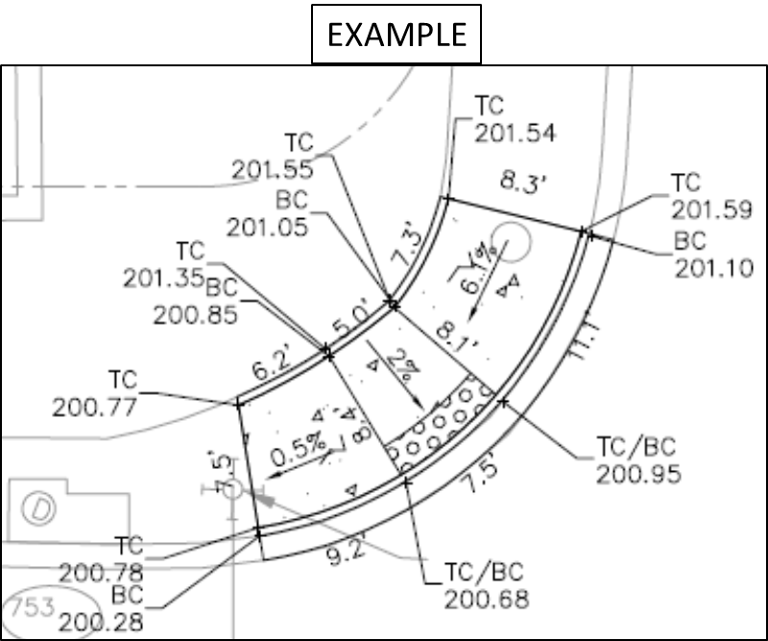
- Provide Pedestrian detectable warning in sidewalk on both sides of CG-9D.
- Provide CG-12 curb ramps at all intersections where there is Pedestrian Shelf. VDOT I&I Memorandum no: IIM-LD-55.16, requires CG-12s where there is a proposed pedestrian shelves at 2% grades whether or not sidewalk is proposed. All Henrico County Typical Road Sections that have Curb and Gutter require a pedestrian shelf. Each CG-12 shall be designed to ensure proposed CG-12 geometrics will work with adjacent roadway design elements to meet current ADA requirements as published by VDOT.
- Depressed Curb no longer allowed.
- CG-12’s are required to be directional.
- Provide top of curb elevations and around:
All cul-de-sacs
All curb returns
Show High Point (H/P and Low Point (L/P) and TC elevations.
- All entrances must be CG-9D and labeled as such on the plans.
- Where pedestrian access routes cross entrances (whether private or public/ commercial), the grade and width of the pedestrian route shall be maintained through the entrance. This means the running slope of the entrance must transition to meet the cross slope of pedestrian route where the two intersect. In the cases of CG-9D entrances, the pedestrian access route may be located beyond the entrance provided additional Right of Way or permanent easement is recorded..
- CG-9D shall project ADA compliant pedestrian crossing area behind driveway. (This standard is in the new Henrico County Design Manual to be published)
Additional Right of Way Required
Pedestrian Access Easement Required
- Residential drive ways shall project ADA compliant pedestrian crossing area behind driveway. (This standard is in the new Henrico County Design Manual to be published)
- Roll-faced curb is not allowed for parking areas.
- Curb cuts are not permitted along drive aisles.
- Valley gutters are not allowed in the public right-of-way.
- Provide profiles based on field-run elevations for all storm sewers located outside of the right-of-way limits.
- Provide an itemized list (including descriptions VDOT nomenclature) of all drainage structures on the plan. This includes IS-1, depth, and inverts.
- Storm water must be collected on-site in curb drop inlets.
- Provide the following information for all curb and gutter/storm sewer systems:
Length of inlet throats.
Type of material (RCP Class III or better in County easements or right-of-way)
Diameter (minimum 15 inches)
Concrete flume transition details from curb to ditch
Details of non-standard structures
Longitudinal slope (minimum allowable is 0.3%)
Maximum length between structures is 300 feet for pipes less than 48” diameter
Indicate whether steps, and/or O-ring pipe are proposed
Inlet shaping (IS-1) required in structures that are in County ROW or in County maintained easements. (This standard is in the new Henrico County Design Manual to be published)
Provide storm sewer information in tabular format on the plans.
- Provide adequate cover for all storm sewers. The minimum allowable cover is:
Nine (9) inches for storm sewer in the right-of-way.
Six (6) inches for storm sewer in easements.
- Provide the following information for all culverts:
Inverts based on field-run elevations
Lengths
Type (RCP Class III or better in County easements or right-of-way)
Inlet and outlet protection
Diameter
Design cover
- DI-3 series inlets must be designed so that the minimum depth of the inlets is equal to or greater than the diameter of the pipe plus 2.67’ (32”).
- DI-4 series inlets are required for all storm sewers greater than 30” diameter.
- The maximum throat length for curb drop inlets in cul-de-sacs is 6 feet.
- Drop inlets are not allowed in the radius of intersections.
- Provide details for JB-1 and any non-standard VDOT inlets.
- Show the dimensions for all outlet protection (length, width, and depth, including filter fabric lining).
- Inlets must have minimum 1 tenth fall from invert to outfall.
- DI-2 inlets are not allowed in County Right of Way.
- Functional drainage must be maintained during all phases of construction.

ADDITIONAL COMMENTS:

Drainage:
- Provide a typical yard swale detail. All yard swales must meet the following criteria:
Longitudinal slope must be at least 1%
Minimum side slope ratio is 3:1
Maximum depth is 18 inches
No longer than 150 feet without a drop inlet. If possible position inlet at Property Line intersections
- For all existing storm sewer systems used as an outfall, provide the following information:
A profile based on field-run elevations beginning at the project’s discharge location and including the existing pipe to the first structure (inlet, manhole, etc.) downstream of the project boundary.
Identification of the size, material and type of all structures along the profile
- Roadside ditches with less than 1% fall need to be paved.
- Gaps between sections of paved ditches are not allowed. Regrade ditch or pave ditch to provide continuous run of paved ditch.

ADDITIONAL COMMENTS:

EASEMENTS / AGREEMENTS:
- Show the location, width, recordation information, and whether private or public for all existing drainage easements.
- All proposed drainage easements must be a minimum of 16 feet wide.
Additional Drainage easement width required due to pipe size and depth.
- Due to depth of storm sewer, additional easement width is required.
- The Deed Book and Page Number must be provided for all proposed off-site drainage & sight distance easements prior to plan approval.
- For commercial/multi-family projects, only runoff that is considered “public” can be contained in a County maintained drainage easement. Storm water from off-site drainage areas that does not contain “public” water must be contained in private drainage easements.
- Show offsite connecting easements.
- Provide a drainage easement through all lakes, ponds, and/or BMP basins that will contain public water. The easement must be at least 16 feet wide and must take the most direct route from the inlet(s) to the outlet(s).
- A Right of Way maintenance agreement must be provided between the developer and the County of Henrico prior to plan approval for irrigation, landscaping, lighting, stamped pavers, etc. within the County right-of-way. This agreement can be found on the Department of Public Works web page at: https://www.henrico.us/pdfs/works/rwmaintenanceagreement2007.pdf.

ADDITIONAL COMMENTS:

Guardrail:
- Show guardrail with proper end treatments where needed.
Provide length and Type of GR required.
- Provide required grading for type GR to include splay and bench for GR.
- All guardrail must be located within right of way or easement.
- Any guardrail that is being replaced must be brought up to current design standards.

ADDITIONAL COMMENTS:

Sidewalk:
- All sidewalk must be located within right of way or easement.
- 4’ sidewalks require pedestrian passing areas at minimum intervals of 200’. Entrances & street intersections are considered pedestrian passing areas (Inlets are not).
- Max cross slope of 2% on all sidewalks and must be carried across all entrances and intersection.
- Design cross slope should be 1.5%.
- Ramps for sidewalks or shared use path shall be equivalent with of path.
- No manholes, hand holds, valve boxes, test boxes, and fire hydrants allowed in sidewalk.

ADDITIONAL COMMENTS:

MISCELLANEOUS

Additional comments may follow upon review of a subsequent submittal.

The Construction Division has completed its review and has no comments at this time.

Reviewed by: xxxxxxxxxx
Date Reviewed: xxxxxxx
Phone Number: 804-727-82xx

