**Project Overview**

**Location:** Hermitage Road from Hilliard Road to Staples Mill Road

**Length:** 2 miles

**Anticipated Cost:**

* **Short-term measures** (Segment’s 2 and 3): $1-$2 million
  + Curb ramp improvements
  + Sidewalk repairs
  + Pedestrian walkways
  + Curb extensions
  + Mid-block crossing at Vernon Avenue
* **Entire Corridor:** $12-$15 million

**Anticipated Schedule:**

* **2025/2026:** Improve/repair existing segments of sidewalks/curb ramps.Build short-term walkways within existing right-of-way to expand connectivity to existing sidewalks.
* **2025/2026:** Evaluate grant funding to address funding shortfalls for remaining segments.
* **2026:** Begin design of future segments based on funding availability.
* Construction of remaining segments to be determined.

**Project Area**

Welcome to the County of Henrico public information meeting on the proposed Hermitage Road Pedestrian and Roadway Improvements study. The purpose of this meeting is to provide an opportunity for citizens or organizations to provide comments. The County wants all members of the community to have the opportunity to participate in public involvement on projects affecting them. Representatives are present to discuss the study and answer your questions.

**Project Description**

The Hermitage Road Pedestrian and Roadway Improvements study proposes several changes along nearly two miles of Hermitage Road from Hilliard Road to Staples Mill Road. The corridor presents some challenges for building sidewalk with several areas of utilities, drainage work, and floodplain conflicts. This effort has determined the feasibility of adding pedestrian accommodations along the corridor and has and developed cost estimates for different segments to identify short and mid-term options for improving pedestrian safety.

The proposed roadway sections shall consist of the following:

* Segment 1: Traditional curb and gutter sidewalk continuing east along Hermitage Road from the existing sidewalk at the Lidl Grocery Store to Oakview Avenue.
* Segment 2: A combination of traditional sidewalk and walkways created by re-purposed, excess pavement between Oakview Avenue and Lourdes Road.
* Segment 3: Traditional sidewalk on the south side of Hermitage Road from Lourdes Road to Alycia Avenue (connecting to existing sidewalk).
* Segment 4: Traditional sidewalk connecting existing sidewalk on the south side of Hermitage Road from Alycia Avenue to Woodman Road.
* Segment 5: Traditional sidewalk on the west side of Hermitage Road from Woodman Road to Hilliard Road.

Other key elements proposed throughout the study corridor include:

* Traffic calming measures along the corridor to encourage lower vehicle speeds and improved driver awareness. Measures include miniature roundabouts, curb extensions, pedestrian refuge islands, and narrow travel lanes.
* Improvements to existing sidewalks, including ADA-compliant curb ramps and repairs as-needed.
* Mid-block crossing accommodations at Oakview Avenue, Lourdes Road, and Vernon Road.
* Stormwater improvements to replace some existing roadside ditches with curb and gutter.
* Re-location of several utility poles, particularly along Segment 4 and Segment 5.

**Hermitage Road Pedestrian and Roadway Improvements**

**Public Information Meeting**

February 26, 2025

5:30 p.m. – 7:00 p.m.

**Elizabeth Holladay Elementary School (Gym)**

7300 Galaxie Road, Richmond, VA 23228

County of Henrico

Department of Public Works

Terrell C. Hughes, P.E. Director

(804) 501-4393

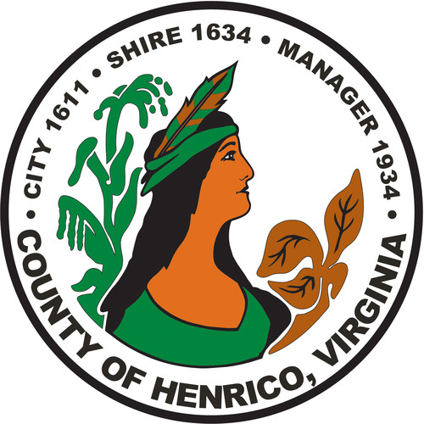

**Get Involved**

The public comment period will close on March 12, 2025, following the public information meeting. County representatives will review and evaluate any information received. Project information shared here is available for review after the public information meeting at the County of Henrico Department of Public Works located at 4305 E. Parham Road, Henrico, Virginia 23228. Comments can also be submitted to Ryan Levering ([lev004@henrico.us](mailto:lev004@henrico.us)) or at the contact address below.

However, information must be postmarked, e-mailed or delivered to the County by March 12, 2025, to be included in the public information meeting record. Comments can either be submitted using the comment form or via the online survey on the County’s website at the QR code:

**Contact Information**

Ryan Levering County of Henrico Public Works

Capital Projects Manager Transportation Development Division

(804) 501-4244 P. O. Box 90775

[LEV004@henrico.us](mailto:LEV004@henrico.us) Henrico, VA 23273-0775

**Environmental Review**

As the design develops the county will review the environmental impacts of the project. As a result of this review, a determination will be made concerning the construction impacts of the project. During construction, all reasonable efforts will be made to protect the environment with respect to dust control, siltation, and erosion. Construction will conform to the County’s specifications and special provisions and the Virginia Department of Soil and Water Conservation regulations.

**Civil Rights**

Representatives from the County are present to discuss the project and answer your questions. It is the responsibility of the County to ensure that all members of the community are afforded the opportunity to provide comments and participate in public decisions on projects affecting them. The County ensures nondiscrimination in all programs and activities in accordance with Title VI of the Civil Rights Act of 1964.

Minature roundabouts constructed within County right-of-way in Henrico’s Charles Glen neighborhood. Mini roundabouts encourage slower vehicle speeds with minimal impacts.

**Right of Way**

Much of the work proposed does not require additional right of way. As the County continues to refine the designs and a clear timeline for construction emerges for these segments, property owners will be informed of the exact location of the easements during the right of way acquisition process and prior to construction.

If you have questions or concerns regarding easement and right of way acquisition process, please contact Ryan Levering, Transportation Development Division via [lev004@henrico.gov](mailto:lev004@henrico.gov) or (804) 501-4244.

**Safety Measure Depictions**

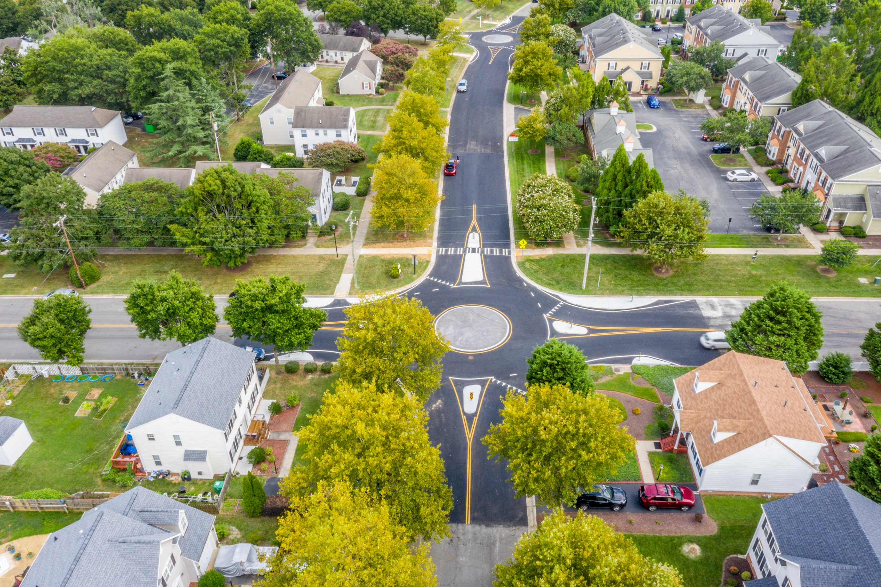

A paved “walkway” as alternatives to traditional curb and gutter sidewalks. Walkways include physical barriers between vehicles and pedestrians, such as curbing or lane delineators.

